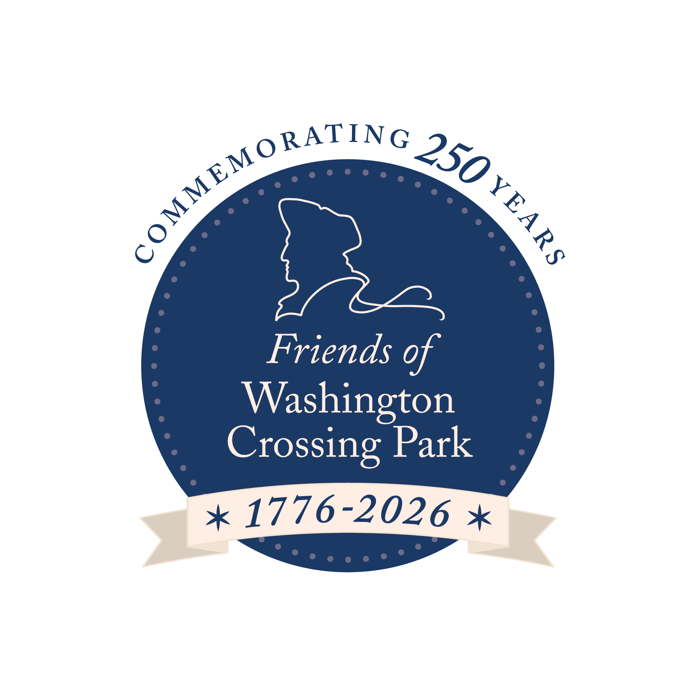

**FOR IMMEDIATE RELEASE**

**Press Contacts:**

Washington Crossing Historic Park, Emily Harris, (267) 417-6451, emily@eharrismktg.com

Independence Seaport Museum, Alexis Furlong, (610) 513-5749, afurlong@phillyseaport.org

## 

## **The Durham Boat Project: A Historic Collaboration for America’s 250th Anniversary**

*Independence Seaport Museum is creating a full-scale replica of Washington’s revolutionary boat used on Christmas Night, which will debut at Washington Crossing Historic Park in 2026.*

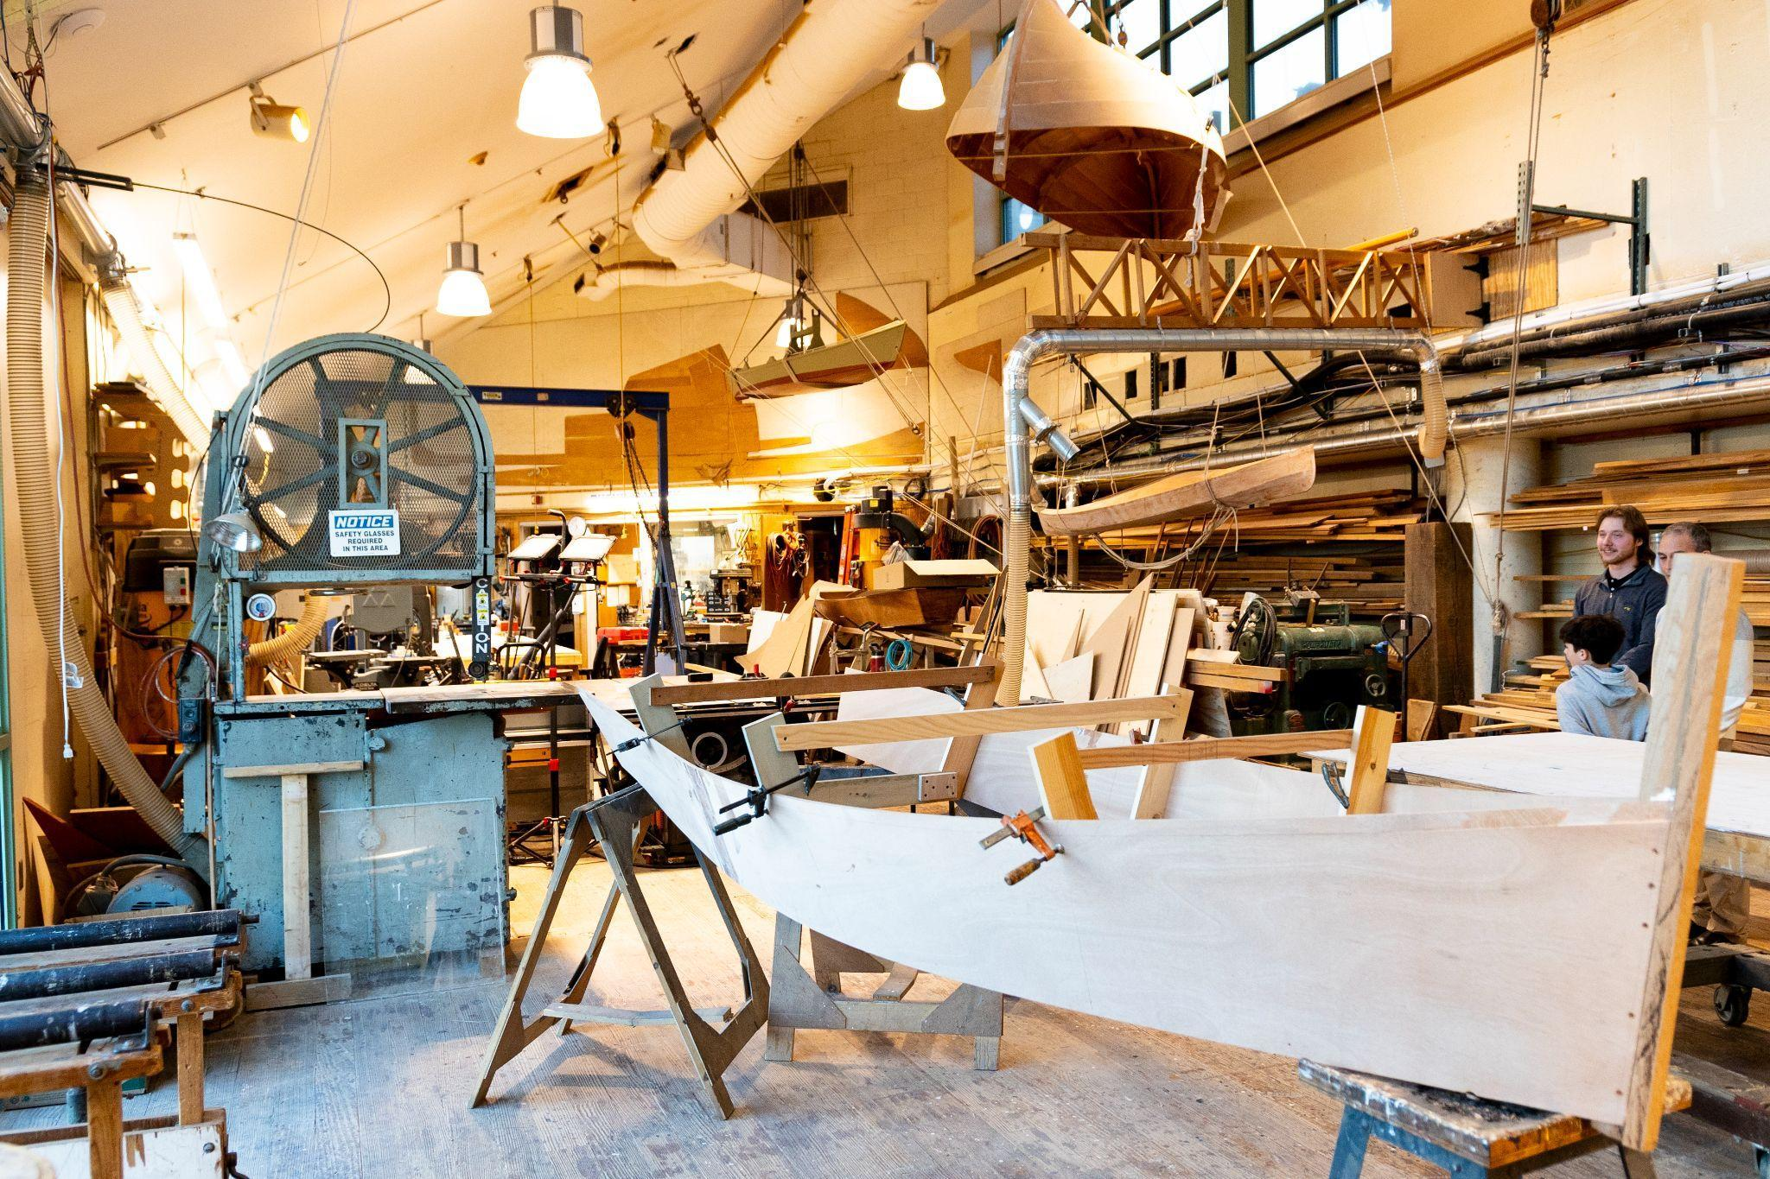

**PHILADELPHIA, PA / WASHINGTON CROSSING, Pa. (May 14, 2025)**–To honor America’s 250th anniversary, the [Friends of Washington Crossing Park](https://www.washingtoncrossingpark.org/about/) (FWCP) and the [Independence Seaport Museum](https://www.phillyseaport.org/) (ISM) have partnered to construct a full-scale, 40-foot replica of a Durham boat—the same type of vessel General George Washington and his troops used to cross the icy Delaware River on December 25, 1776. The project will feature public programs and hands-on experiences leading up to the 2026 unveiling of the replica boat—an interactive centerpiece for Washington Crossing Historic Park’s tours, events, and educational programs.

“This project brings the bold spirit of Washington’s crossing to life in an unforgettable way,” said [Jennifer Martin](https://www.washingtoncrossingpark.org/staff-bio-jennifer-martin/), Executive Director of Friends of Washington Crossing Park. “By combining historic craftsmanship with immersive interpretation, we’re not only honoring the past—we’re creating new opportunities for visitors of all ages to connect with the story of the American Revolution.”

This initiative, known as [*The Durham Boat Project*](https://www.washingtoncrossingpark.org/the-durham-boat-project/), will begin in May 2025 and culminate in May 2026 with the launch and unveiling of the completed boat at Washington Crossing Historic Park’s [Durham Boat Barn](https://www.washingtoncrossingpark.org/park/the-village-lower-park/) in Bucks County. This exciting project is being brought to life thanks to the generous support of [The McLean Contributionship](https://www.mcleancontributionship.org/), [Connelly Foundation](https://www.connellyfdn.org/), Albert W. Bader Foundation, Chris and Mary Jane Beck, and Gordon and Barbara Heiser.

“The Seaport Boat Shop at Independence Seaport Museum is excited to partner with Friends of Washington Crossing Park to replicate the 40’ Durham boat in celebration of the country’s Semiquincentennial,” says Dave Dormond, Director of the Seaport Boat Shop and Waterfront Operations. “This vessel symbolizes not only the effort and determination of those who fought for independence but also the skills and craftsmanship of local shipwrights who strived to build a stronger and more prosperous Philadelphia through its connection to the Delaware River.”

The replica boat will be built at ISM’s [Seaport Boat Shop](https://www.phillyseaport.org/the-seaport-boat-shop/) in Philadelphia using traditional materials and techniques wherever possible. In the spirit of public history and community involvement, the museum will host monthly [Table Saw Talks](https://www.phillyseaport.org/table-saw-talks/)—starting with a kickoff event on Sunday, May 18, 2025, at 10:00 AM—offering behind-the-scenes insight into the craftsmanship of wooden boatbuilding. These engaging events will continue on the second Sunday of each month through May 2026.

The completed Durham boat will be permanently installed along a new interpretive trail at Washington Crossing Historic Park, designed in collaboration with the [Department of Conservation and Natural Resources](https://www.pa.gov/agencies/dcnr.html) and [106 Group](https://106group.com/), leaders in cultural heritage planning. This hands-on, ADA-accessible exhibit will allow visitors to climb aboard the boat and immerse themselves in the story of the soldiers who crossed the Delaware in a bold bid for American independence.

Once in place, the replica will become a dynamic centerpiece of the park’s interpretive programming, including field trips, reenactments, and guided tours. It will serve as a key element of the Park’s [*Colonial Days*](https://www.washingtoncrossingpark.org/events/colonialdays/) and new [*Rescuing the Revolution*](https://www.washingtoncrossingpark.org/rescuing-the-revolution-field-trip-tour/) field trip program, presented in partnership with Americana Corner’s [Preserving America](https://www.americanacorner.com/partners/friends-washington-crossing-park) initiative. Each year, more than 10,000 schoolchildren will have the opportunity to engage directly with the boat, don period clothing, and participate in activities that bring Revolutionary history to life. Throughout the yearlong construction process, FWCP and ISM will also host pop-up events at key milestones, allowing visitors to lend a hand and contribute to this historic build.

Whether you’re a history buff, student, family, or curious explorer, the *Durham Boat Project* offers a rare chance to witness—and even participate in—the making of a monumental piece of American history. Experience history in the making as FWCP and ISM bring Washington’s crossing to life—one plank at a time.

**ABOUT FWCP**: The Friends of Washington Crossing Park shares the powerful story of General George Washington’s daring crossing of the Delaware River on Christmas Night 1776 and interprets its ongoing impact on world history for both today’s citizens and future generations. Through the fundraising and the generous support of our donors and members, we are able to maintain and sustain this significant historic site and welcome thousands of schoolchildren, families, individuals and groups every year. In partnership with the Department of Conservation and Natural Resources, the Friends offer guided interpretive tours and educational programming in the park. The group also holds a number of annual events, several fundraisers and more. Visit [washingtoncrossingpark.org/](http://washingtoncrossingpark.org/) to learn more.

**ABOUT ISM:** The Independence Seaport Museum (ISM), founded in 1960 as the Philadelphia Maritime Museum, encourages visitors to discover Philadelphia's river of history and world of connections. Stewards of the *Olympia*, a nineteenth-century cruiser, and the *Becuna*, a World War II-era submarine, ISM is home to interactive and award-winning exhibitions, one of the largest collections of historic maritime artifacts in the world and a boatbuilding workshop. Accredited by the American Association of Museums since the 1970s, it is a premier, year-round destination adjacent to Spruce Street Harbor Park on Penn’s Landing. Visit daily from 10 a.m. to 5 p.m. and see our full schedule of programs and events at phillyseaport.org. Visit <https://www.phillyseaport.org/admissons-hours-of-operation/> to learn about ticket packages and guided tour options.

# # #